**Spring Boot Interview Questions for 5 Years Experience**

Author: [Ramesh Fadatare](https://www.blogger.com/profile/14691512106162803120)

[**Interview**](https://www.javaguides.net/search/label/Interview?&max-results=10) [**Spring Boot**](https://www.javaguides.net/search/label/Spring%20Boot?&max-results=10)

In this article, we will discuss 30+ important Spring boot interview questions and answers for beginners and experienced candidates.

Check out [Spring Boot Interview Questions for 2 Years Experience](https://www.javaguides.net/2023/07/spring-boot-interview-questions.html)

If you want to learn and master in Spring Boot then check out [Beginners to Master Spring Boot Tutorial](http://www.javaguides.net/p/spring-boot-tutorial.html).

**YouTube Video - Spring Boot Interview Questions**

**1. What is the Spring Boot?**

Spring Boot is basically an extension of the Spring framework which eliminated the boilerplate configurations required for setting up a Spring application.  
  
Spring Boot is an opinionated framework that helps developers build Spring-based applications quickly and easily. The main goal of Spring Boot is to quickly create Spring-based applications without requiring developers to write the same boilerplate configuration again and again.

Read more about Spring Boot at [Getting Started with Spring Boot](https://www.javaguides.net/p/spring-boot-tutorial.html)

**2. Explain a few important Spring Boot Key features?**

Let me a list of a few key features of the Spring boot and we will discuss each key feature briefly.

1. Spring Boot starters
2. Spring Boot autoconfiguration
3. Elegant configuration management
4. Spring Boot Actuator
5. Easy-to-use embedded servlet container support

**1. Spring Boot Starters**

Starters are a set of opinionated dependencies that simplify dependency management. They encapsulate common configurations and dependencies needed for specific functionalities, such as database connectivity, security, web services, and more. Starters make it easy to add required dependencies with minimal effort and reduce version compatibility issues.

For example, the *spring-boot-starter-data-jpa* starter module includes all the dependencies required to use Spring Data JPA, along with Hibernate library dependencies, as Hibernate is the most commonly used JPA implementation.  
  
One more example, when we add the *spring-boot-starter-web* dependency, it will by default pull all the commonly used libraries while developing Spring MVC applications, such as *spring-webmvc*, *jackson-json*, *validation-api*, and *tomcat*. Not only does the *spring-boot-starter-web* add all these libraries but it also configures the commonly registered beans like DispatcherServlet, ResourceHandlers, MessageSource, etc. with sensible defaults.

Read more about starters on [Important Spring Boot Starters with Examples](http://www.javaguides.net/2018/09/important-spring-boot-starters-with-examples.html)

**2. Spring Boot Autoconfiguration**

Spring Boot provides automatic configuration for various components based on the classpath dependencies present in the project. It eliminates the need for manual configuration, reduces boilerplate code, and simplifies the setup process.

For example, if you have the *spring-webmvc* dependency in your classpath, Spring Boot assumes you are trying to build a SpringMVC-based web application and automatically tries to register *DispatcherServlet* if it is not already registered.

If you have any embedded database drivers in the classpath, such as H2 or HSQL, and if you haven’t configured a *DataSource* bean explicitly, then Spring Boot will automatically register a *DataSource* bean using in-memory database settings.

You will learn more about autoconfiguration at [What is Spring Boot Auto Configuration?](http://www.springboottutorial.com/spring-boot-auto-configuration)

**3. Elegant Configuration Management**

Spring Boot allows you to externalize configuration properties, such as database connection details, server port, and logging settings. It supports various configuration formats like properties files, YAML files, environment variables, and more. The externalized configuration makes it easier to configure and manage application properties in different environments.

**4. Spring Boot Actuator**

Spring Boot Actuator provides production-ready features out of the box. It allows developers to monitor and manage the application using built-in endpoints for health checks, metrics, logging, and more. Traditional Spring does not provide these features by default.

Read more about Spring Boot Actuator on [Spring Boot Actuator](https://www.baeldung.com/spring-boot-actuators)

**5. Easy-to-Use Embedded Servlet Container Support**

Traditionally, while building web applications, you need to create a WAR file of your spring project and then deploy them on external servers like Tomcat, WildFly, etc. Spring Boot allows you to package your application as a standalone JAR file. It includes an embedded servlet container (Tomcat, Jetty, or Undertow) by default, making it easy to deploy and run applications without requiring an external server.

**3. What is the Difference Between Spring and Spring Boot**

[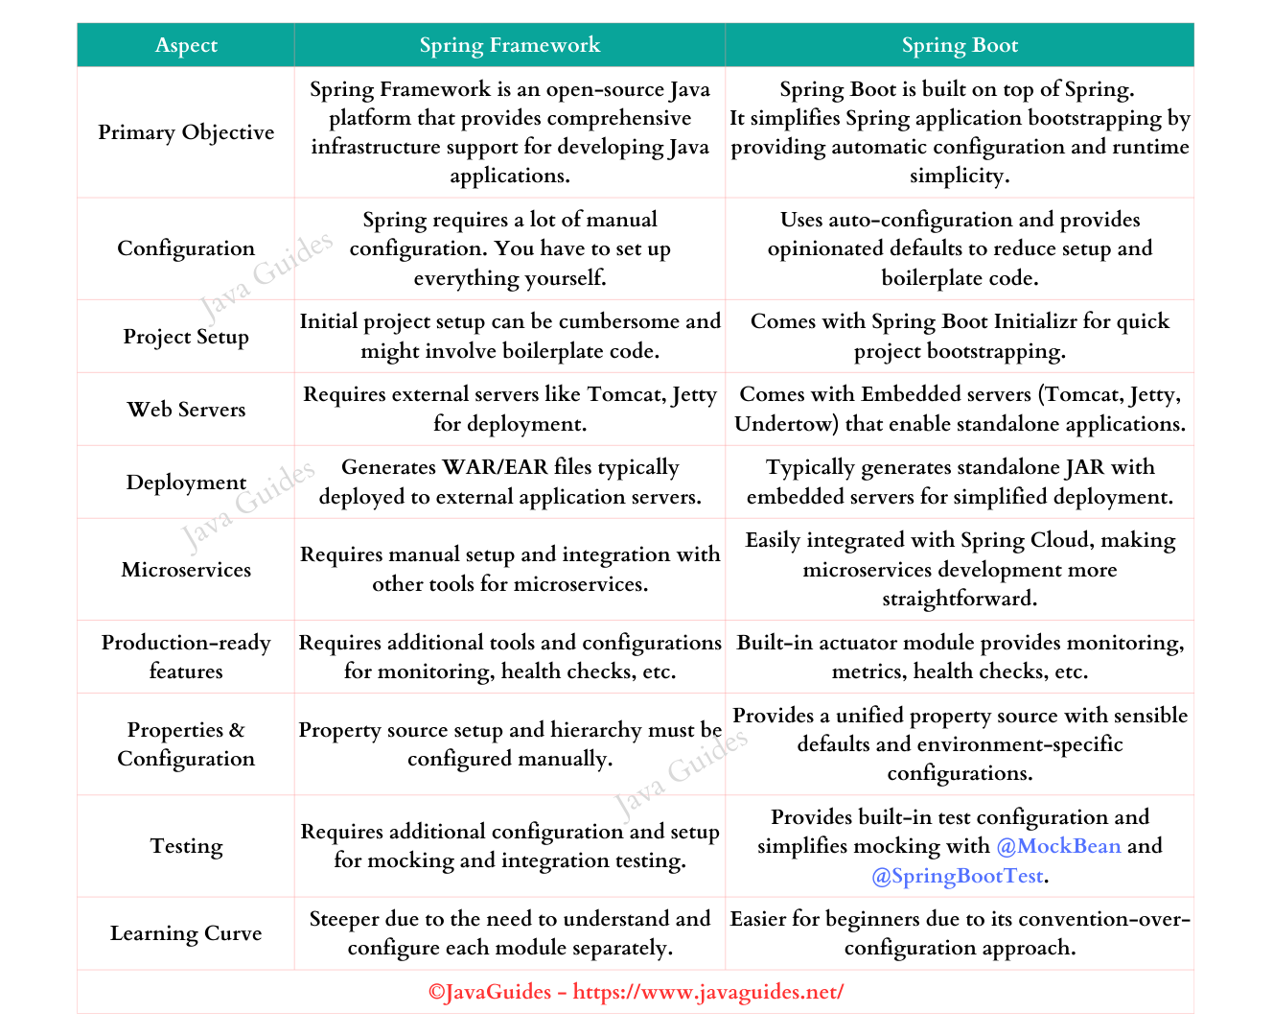](https://blogger.googleusercontent.com/img/b/R29vZ2xl/AVvXsEiNJNhBys37BqzLQT8T3yMEqU85cWcEkARy0ltf3zp-yJ_u8Ns4tFJycGVI6PVo0nRsMP9i9hjHA5eRIDYLBoHH42msnHo8oC0GKsjh_EfEbH4c7azgp52hvwCt7u11pHiKVGFyls-KpR4CCLZnCtOlZnsIDv-gmCgwPNC6yW7oa1FVZjlVLqkEHUD6zBw/s1328/Spring%20vs%20Spring%20Boot%20-%20Java%20Guides%20Net.png)

Learn more about the differences: [Difference Between Spring and Spring Boot](https://www.javaguides.net/2023/08/difference-between-spring-and-spring-boot.html)

**4. Explain Spring vs Spring MVC vs Spring Boot**

[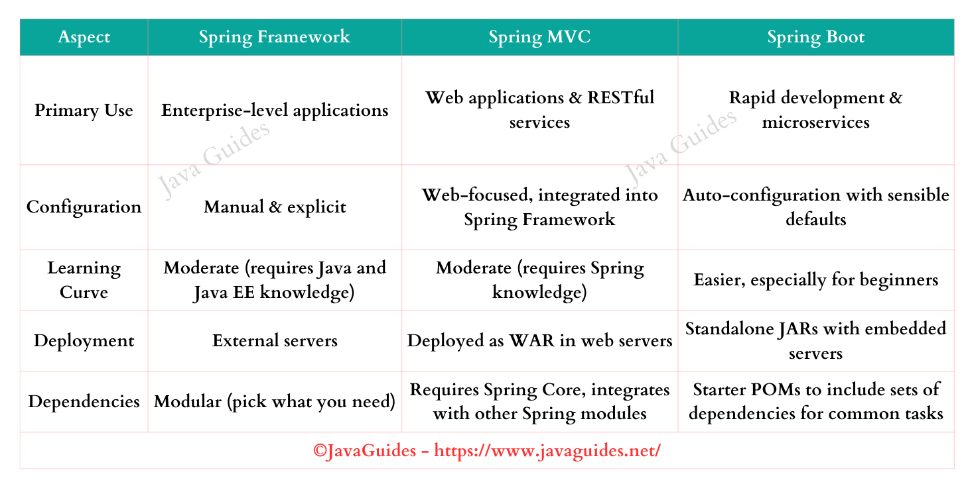](https://blogger.googleusercontent.com/img/b/R29vZ2xl/AVvXsEhKQNLhvwX5Zqrg9uNYSXv9WaHkN8t3Lti8VQWc27_HbVruc-1IvTn_cn3a950MJHsencbtzvuBHZ_AObURjHmb6Biiq5jxhtCZZ1ONFZE35rW9ZAjpsP7yC6OBfZoUwg-yKyt9RugXXsemiPOZRy7PyvLg5PNehDGQKyM2rzUKfs2mdLKlv3HA6RQ-kYw/s1462/Spring%20vs%20spring%20mvc%20vs%20Spring%20Boot%20-%20Java%20Guides.png)

Learn more here: [Spring vs Spring MVC vs Spring Boot](https://www.javaguides.net/2023/08/spring-vs-spring-mvc-vs-spring-boot.html)

**5. What is Spring Boot Auto-configuration?**

Spring Boot Auto-configuration is a feature that automatically configures your Spring application based on the libraries you have in your project's classpath. It reduces the need for specifying beans in the configuration file.

**Why do we need Spring Boot Auto Configuration?**

-> Spring-based applications have a lot of configuration.

-> When we use Spring MVC, we need to configure

- Component scan,

- Dispatcher Servlet

- View resolver

- Web jars(for delivering static content) among other things.

-> When we use Hibernate/JPA, we would need to configure a

- data source

- entity manager factory/session factory

- transaction manager among a host of other things.

-> When you use cache

- Cache configuration

-> When you use Message Queue

- Message queue configuration

-> When you use a NoSQL database

- NoSQL database configuration

**Spring Boot:** Can we think differently?

Spring Boot brings in a new thought process around this:

-> Can we bring more intelligence into this? When a spring MVC jar is added to an application,

    can we auto-configure some beans automatically?

-> How about auto-configuring a Data Source if Hibernate jar is on the classpath?

-> How about auto-configuring a Dispatcher Servlet if the Spring MVC jar is on the classpath?

One more example, if *HSQLDB* is present on your classpath and you have not configured any database manually, Spring will auto-configure an in-memory database for you.

The Spring Boot auto-configuration feature tries to automatically configure your Spring application based upon the JAR dependency you have added in the classpath.

Learn more about Spring Boot Auto Configuration at [Spring Boot Auto Configuration | Example](https://youtu.be/qm_lBjlwQLY)

**6. What are the different ways to create a Spring Boot application?**

Different ways to create Spring boot project:

**1. Using Spring Initializr** - Create a Spring boot project using Spring Initializr and import in any IDE - Eclipse STS, Eclipse, IntelliJ idea, VSCode, Netbeans

**2. Using Spring Starter Project in STS (Eclipse) -** You can directly create a Spring boot project in STS using the Spring Starter Project option.

**3. Spring Boot CLI -** The Spring Boot CLI is a command-line tool that you can use if you want to quickly develop a Spring application.

**7. Explain @SpringBootApplication, @Configuration and @ComponentScan annotations**

The [@SpringBootApplication](http://www.javaguides.net/2018/09/spring-boot-springbootapplication-annotation-with-example.html) annotation indicates a configuration class that declares one or more @Bean methods and also triggers auto-configuration and component scanning. This is a convenience annotation that is equivalent to declaring below three annotations:

@SpringBootApplication = @Configuration + @EnableAutoConfiguration + @ComponentScan

[@Configuration](https://www.javaguides.net/2018/09/spring-configuration-annotation-with-example.html): The @Configuration annotation indicates that the class contains bean configurations and should be processed by the Spring IoC container. It allows you to define beans and their dependencies using annotations like [@Bean](https://www.javaguides.net/2023/01/spring-boot-bean-annotation-example.html).  
  
[@EnableAutoConfiguration](https://www.javaguides.net/2018/09/spring-boot-enableautoconfiguration-annotation-with-example.html): The *@EnableAutoConfiguration* annotation enables Spring Boot's auto-configuration mechanism. It automatically configures the Spring application based on the classpath dependencies, project settings, and environment. Auto-configuration eliminates the need for manual configuration and reduces boilerplate code.  
  
**@ComponentScan:** The *@ComponentScan* annotation tells Spring where to look for components (such as controllers, services, and repositories) to be managed by the Spring IoC container. It scans the specified packages and registers the annotated classes as beans.

**8. What are Spring boot starters and name a few important Spring boot starter dependencies?**

Starters are a set of convenient dependency descriptors that you can include in your application. You get a one-stop shop for all the Spring and related technology that you need, without having to hunt through sample code and copy-paste loads of dependency descriptors.

For example, while developing the REST service or web application; we can use libraries like Spring MVC, Tomcat, and Jackson – a lot of dependencies for a single application. The *spring-boot-starter-web* starter can help to reduce the number of manually added dependencies just by adding a *spring-boot-starter-web* dependency.

So instead of manually specifying the dependencies just add one *spring-boot-starter-web* starter to your spring boot application:

<dependency>

<groupId>org.springframework.boot</groupId>

<artifactId>spring-boot-starter-web</artifactId>

</dependency>

Few commonly used Spring boot starters:

*spring-boot-starter*: core starter, including auto-configuration support, logging, and YAML

*spring-boot-starter-aop*: for aspect-oriented programming with Spring AOP and AspectJ

*spring-boot-starter-data-jpa*: for using Spring Data JPA with Hibernate

*spring-boot-starter-security*: for using Spring Security

*spring-boot-starter-test*: for testing Spring Boot applications

*spring-boot-starter-web*: for building web, including RESTful, applications using Spring MVC.

spring-boot-starter-data-mongodb: Starter for using MongoDB document-oriented database and Spring Data MongoDB

spring-boot-starter-data-rest: Starter for exposing Spring Data repositories over REST using Spring Data REST

spring-boot-starter-webflux: Starter for building WebFlux applications using Spring Framework’s Reactive Web support

You can find all the Spring Boot Starters at [Important Spring Boot Starters with Examples](https://www.javaguides.net/2018/09/important-spring-boot-starters-with-examples.html)

**9. How does Spring Enable Creating Production-Ready Applications in a Quick Time?**

Spring Boot aims to enable production-ready applications in a quick time. Spring Boot provides a few non-functional features out of the box like caching, logging, monitoring, and embedded servers.

* **spring-boot-starter-actuator** - To use advanced features like monitoring & tracing to your application out of the box
* **spring-boot-starter-undertow, spring-boot-starter-jetty, spring-boot-starter-tomcat** - To pick your specific choice of Embedded Servlet Container
* **spring-boot-starter-logging** - For Logging using log back
* **spring-boot-starter-cache** - Enabling Spring Framework’s caching support

**10. What Is the Minimum Baseline Java Version for Spring Boot 3?**

Spring Boot 3.0 requires Java 17 or later. It also requires Spring Framework 6.0.

Recommended Reading - [Spring Boot 3.0 Goes GA - Official](https://spring.io/blog/2022/11/24/spring-boot-3-0-goes-ga)

**11. What are Different Ways of Running Spring Boot Application?**

Spring Boot offers several ways of running Spring Boot applications. I would like to suggest five ways we can run the Spring Boot Application

1. Running from an IDE
2. Running as a Packaged Application
3. Using the Maven Plugin
4. Using External Tomcat
5. Using the Gradle Plugin

Read more at [Different Ways of Running Spring Boot Application](http://www.javaguides.net/2018/09/different-ways-of-running-spring-boot-appilcation.html)

**12. Name all Spring Boot Annotations?**

[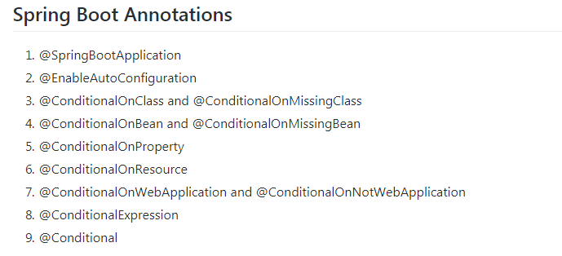](https://blogger.googleusercontent.com/img/b/R29vZ2xl/AVvXsEg2bk9XBeRCiN64OGu9wafrzLXZgYS545mJr3xc0a9Fo8aIbVkkFdDBHjkBqMuFYUnIi1bYu1p3F4Hkv5D-OVcwkjp_dTTunhDJyI4Pu_rc0oGRXQ92kVSSYPTRhZrH7VUNjxcTLScFris/s1600/spring-boot-annotations.PNG)

Read more about each Spring Boot annotation at [Spring Boot Annotations with Examples](http://www.javaguides.net/2018/10/spring-boot-annotations.html)

**13. @SpringBootApplication vs @EnableAutoConfiguration Annotation?**

[@EnableAutoConfiguration](http://www.javaguides.net/2018/09/spring-boot-enableautoconfiguration-annotation-with-example.html) is to enable the automatic configuration feature of the Spring Boot application which automatically configures things if certain classes are present in Classpath.

For example, it can configure Thymeleaf, TemplateResolver, and ViewResolver if Thymeleaf is present in the classpath.

[@EnableAutoConfiguration](http://www.javaguides.net/2018/09/spring-boot-enableautoconfiguration-annotation-with-example.html) also combines @Configuration and @ComponentScan annotations to enable Java-based configuration and component scanning in your project

On the other hand, [@SpringBootApplication](http://www.javaguides.net/2018/09/spring-boot-springbootapplication-annotation-with-example.html) annotation indicates a configuration class that declares one or more @Bean methods and also triggers auto-configuration and component scanning. This is a convenience annotation that is equivalent to declaring @Configuration, [@EnableAutoConfiguration](http://www.javaguides.net/2018/09/spring-boot-enableautoconfiguration-annotation-with-example.html), and @ComponentScan.

[](https://blogger.googleusercontent.com/img/b/R29vZ2xl/AVvXsEh_tb5L2G4ryWCKGK2BDSVefEY_QW0n-yY_8JKt1tX9V5UTvYUcxu1ZwDezCpzZ2Xz9Pyx4JH-Qm7coUsT6DuWQYPhsb4xn6M6pGkhcnnFC6dgPyWa0XxZ27MyuJQp0A91j4IEUCQU2KI0/s1600/springbootapplication.png)

Read more:[@EnableAutoConfiguration Annotation with Example](http://www.javaguides.net/2018/09/spring-boot-enableautoconfiguration-annotation-with-example.html)

Read more: [Spring Boot @SpringBootApplication Annotation with Example](http://www.javaguides.net/2018/09/spring-boot-springbootapplication-annotation-with-example.html)

**14. Why do we need a spring-boot-maven plugin?**

The Spring Boot Maven plugin provides many convenient features:

* It collects all the jars on the classpath and builds a single, runnable "über-jar", which makes it more convenient to execute and transport your service.
* It searches for the public static void *main()* method to flag as a runnable class.
* It provides a built-in dependency resolver that sets the version number to match Spring Boot dependencies. You can override any version you wish, but it will default to Boot’s chosen set of versions.

The Spring Boot Plugin has the following goals.

* *spring-boot:run* runs your Spring Boot application.
* *spring-boot:repackage* repackages your jar/war to be executable.
* *spring-boot:start* and *spring-boot:stop* to manage the lifecycle of your Spring Boot application (i.e. for integration tests).
* *spring-boot:build-info* generates build information that can be used by the Actuator.

Read more about Spring Boot Plugin at [https://docs.spring.io/spring-boot/docs/current/maven-plugin](https://docs.spring.io/spring-boot/docs/current/maven-plugin/)

**15. What is the Spring Boot Actuator and its Features?**

Spring Boot Actuator provides production-ready features for monitoring and managing Spring Boot applications. It offers a set of built-in endpoints and metrics that allow you to gather valuable insights into the health, performance, and management of your application.   
  
**Here are some key features provided by Spring Boot Actuator:**   
**Health Monitoring:** The actuator exposes a */health* endpoint that provides information about the health status of your application. It can indicate whether your application is up and running, any potential issues, and detailed health checks for different components, such as the database, cache, and message brokers.  
  
**Metrics Collection:** The actuator collects various metrics about your application's performance and resource utilization. It exposes endpoints like */metric*s and */prometheus* to retrieve information about HTTP request counts, memory usage, thread pool statistics, database connection pool usage, and more. These metrics can be integrated with monitoring systems like Prometheus, Graphite, or Micrometer.  
  
**Auditing and Tracing:** Actuator allows you to track and monitor the activities happening within your application. It provides an */auditevents* endpoint to view audit events like login attempts, database changes, or any custom events. Additionally, Actuator integrates with distributed tracing systems like Zipkin or Spring Cloud Sleuth to trace requests as they flow through different components.  
  
**Environment Information:** The actuator exposes an */info* endpoint that displays general information about your application, such as version numbers, build details, and any custom information you want to include. It is useful for providing diagnostic details about your application in runtime environments.  
  
**Configuration Management:** Actuator provides an */configprops* endpoint that lists all the configuration properties used in your application. It helps in understanding the current configuration state and identifying potential issues or inconsistencies.  
  
**Remote Management:** Actuator allows you to manage and interact with your application remotely. It provides various endpoints, such as */shutdown* to gracefully shut down the application, /restart to restart the application, and */actuator* to list all available endpoints. These endpoints can be secured using Spring Security for proper access control.  
  
**Enabling the Actuator:**The simplest way to enable the features is to add a dependency to the *spring-boot-starter-actuator* dependency.

<dependency>

<groupId>org.springframework.boot</groupId>

<artifactId>spring-boot-starter-actuator</artifactId>

</dependency>

For Gradle, use the following declaration:

dependencies {

compile("org.springframework.boot:spring-boot-starter-actuator")

}

**16. How to Use Jetty Instead of Tomcat in Spring-Boot-Starter-Web?**

To use Jetty instead of Tomcat in spring-boot-starter-web:

* Exclude Tomcat from the spring-boot-starter-web dependency.
* Add the spring-boot-starter-jetty dependency.

Here's a Maven example:

<!-- Spring Boot Web Starter with Tomcat excluded -->

<dependency>

<groupId>org.springframework.boot</groupId>

<artifactId>spring-boot-starter-web</artifactId>

<exclusions>

<exclusion>

<groupId>org.springframework.boot</groupId>

<artifactId>spring-boot-starter-tomcat</artifactId>

</exclusion>

</exclusions>

</dependency>

<!-- Add Spring Boot Jetty Starter -->

<dependency>

<groupId>org.springframework.boot</groupId>

<artifactId>spring-boot-starter-jetty</artifactId>

</dependency>

Once these changes are made, Spring Boot will automatically use Jetty as the embedded server when the application starts.

**17. How to generate a WAR file with Spring Boot?**

I suggest below three steps to generate and deploy the Spring Boot WAR file.

1. Set the packaging type to *war* in Maven build tool:

<packaging>war</packaging>

1. Add **spring-boot-starter-tomcat** as the **provided** scope

<dependency>

<groupId>org.springframework.boot</groupId>

<artifactId>spring-boot-starter-tomcat</artifactId>

<scope>provided</scope>

</dependency>

1. Spring Boot Application or *Main* class extends *SpringBootServletInitializer*

import org.springframework.boot.SpringApplication;

import org.springframework.boot.autoconfigure.SpringBootApplication;

import org.springframework.boot.builder.SpringApplicationBuilder;

import org.springframework.boot.web.servlet.support.SpringBootServletInitializer;

@SpringBootApplication

public class Springboot2WebappJspApplication extends SpringBootServletInitializer{

@Override

protected SpringApplicationBuilder configure(SpringApplicationBuilder application) {

return application.sources(Springboot2WebappJspApplication.class);

}

public static void main(String[] args) {

SpringApplication.run(Springboot2WebappJspApplication.class, args);

}

}

Learn with a complete example at [Spring Boot 2 Deploy WAR file to External Tomcat](http://www.javaguides.net/2018/09/spring-boot-deploy-war-file-to-external-tomcat.html).

**18. How many types of projects we can create using Spring Boot?**

We can create 3 types of projects using Spring boot starter dependencies.

3 types of Spring boot applications:

1. If *we have a spring-boot-starter* dependency in a classpath then the spring boot application comes under the **default** category.
2. If we have *spring-boot-starter-web* dependency in a classpath then the spring boot application comes under the **servlet** category.
3. If we have a *spring-boot-starter-webflux* dependency in a classpath then the spring boot application comes under the **reactive** category.

**19. How to Change Default Embedded Tomcat Server Port and Context Path in Spring Boot Application?**

By default, the embedded tomcat server starts on port *8080* and by default, the context path is “/”. Now let's change the default port and context path by defining properties in an **application.properties** file -

*/src/main/resources/application.properties*

server.port=8080

server.servlet.context-path=/springboot-webapp

[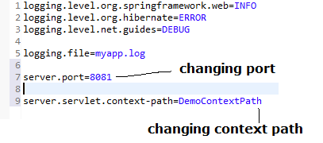](https://blogger.googleusercontent.com/img/b/R29vZ2xl/AVvXsEi9_HGpJy5HyEd0nHF2mEvNtyZ8R9qM98jA8jNTOKucKlJoNDHQsVGb1ZnIvLZ6sl16PFCdAMxAswKTQAhBIBhmFLbDrICfXL_uLPgiLh9KqnVixAsKxfrzdyQ0RuDBfMORhDw3fevS0n8/s1600/server-port-conext-path.PNG)

Read more at [Spring Boot How to Change Port and Context Path](http://www.javaguides.net/2018/09/spring-boot-how-to-change-port-and-context-path.html).

**20. What Embedded servers does Spring Boot support?**

Spring Boot provides support for several embedded servers out-of-the-box. These embedded servers allow you to package your Spring Boot application as a standalone executable JAR file, containing the application and the server runtime.  
  
Here are the embedded servers supported by Spring Boot:   
**Apache Tomcat:** Tomcat is the default embedded server in Spring Boot. It provides a robust and widely used HTTP server and servlet container. Spring Boot uses Tomcat as the default embedded server when you include the spring-boot-starter-web dependency.  
  
**Jetty:** Jetty is another popular choice for embedded servers. It is lightweight, fast, and has a small memory footprint. Spring Boot provides support for Jetty through the spring-boot-starter-jetty dependency.  
  
**Undertow:** Undertow is a high-performance web server designed for modern applications. It is known for its scalability and low resource consumption. Spring Boot offers support for Undertow through the spring-boot-starter-undertow dependency.  
  
By default, when you create a Spring Boot application, it uses **Apache Tomcat** as the embedded server. However, you can easily switch to Jetty or Undertow by excluding the Tomcat dependency and including the desired server dependency in your project's build configuration.

**21. How to use logging with Spring Boot?**

We can use logging with Spring Boot by specifying log levels on the **application.properties** file. Spring Boot loads this file when it exists in the classpath and it can be used to configure both Spring Boot and application code.

Spring Boot, by default, includes **spring-boot-starter-logging** as a transitive dependency for the **spring-boot-starter** module. By default, Spring Boot includes *SLF4J* along with *Logback* implementations.

If *Logback* is available, Spring Boot will choose it as the logging handler. You can easily configure logging levels within the application.properties file without having to create logging provider-specific configuration files such as *logback.xml* or *log4j.properties*.

logging.level.org.springframework.web=INFO

logging.level.org.hibernate=ERROR

logging.level.net.guides=DEBUG

Read more at [Spring Boot 2 Logging SLF4j Logback and LOG4j2 Example](http://www.javaguides.net/2018/09/spring-boot-2-logging-slf4j-logback-and-log4j-example.html).

**22. What is the Spring Boot Starter Parent and How to Use it?**

All Spring Boot projects typically use spring-boot-starter-parent as the parent in pom.xml.

<parent>

<groupId>org.springframework.boot</groupId>

<artifactId>spring-boot-starter-parent</artifactId>

<version>2.0.4.RELEASE</version>

</parent>

spring-boot-starter-parent allows us to manage the following things for multiple child projects and modules:

* Configuration - Java Version and Other Properties
* Dependency Management - Version of dependencies
* Default Plugin Configuration

We should need to specify only the Spring Boot version number on this dependency. If you import additional starters, you can safely omit the version number.

[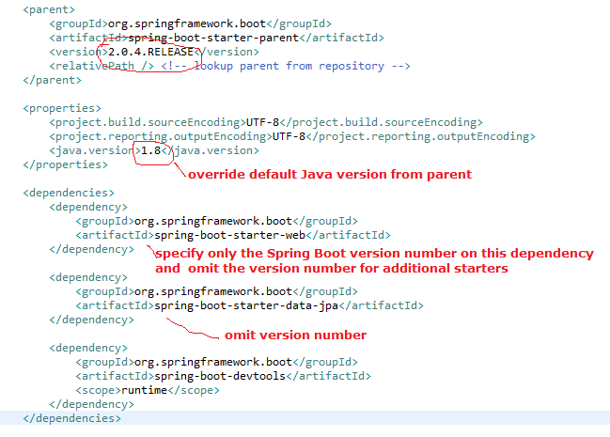](https://blogger.googleusercontent.com/img/b/R29vZ2xl/AVvXsEgYLUpkjaUelaluHbwYwCmT0dabS2g7gl3i-k2daS73GBjSXuzUux2m0tau8YN_iHL7wceXvrJhhJ9aQ1GQge5LS_9g9TWhF0AsxT7EtIFPAUkcQwn7Ng3j1Ju7kZz9sU6Sj6UgKlkSWSw/s1600/spring-boot-starter-parent.PNG)

Read more about spring-boot-starter-parent at [Overview of Spring Boot Starter Parent](http://www.javaguides.net/2018/09/overview-of-spring-boot-starter-parent.html).

**23. How to Write Integration Tests in Spring Boot Application?**

As the name suggests, integration tests focus on integrating different layers of the application. That also means no mocking is involved.

Spring Boot provides @SpringBootTest annotation for Integration testing. This annotation creates an application context and loads the full application context.

@SpringBootTest will bootstrap the full application context, which means we can @Autowire any bean that's picked up by component scanning into our Integration tests.

Read more about Integration tests with a complete example: [Spring Boot Integration Testing CRUD REST API with MySQL Database](https://www.javaguides.net/2022/03/spring-boot-integration-testing-mysql-crud-rest-api-tutorial.html)

**24. How to Test Spring MVC Controllers?**

SpringBoot provides *@WebMvcTest* annotation to test Spring MVC Controllers. Also, the @WebMvcTest annotation-based test runs faster because it will load only the specified controller and its dependencies only without loading the entire application.

Reference: [@SpringBootTest vs @WebMvcTest](https://www.javaguides.net/2022/03/springboottest-vs-webmvctest.html)

**25. @SpringBootTest vs @WebMvcTest?**

*@SpringBootTest* annotation loads the full application context so that we can able to test various components. So basically, the *@SpringBootTest* annotation tells Spring Boot to look for the main configuration class (one with @SpringBootApplication, for instance) and use that to start a Spring application context.  
  
*@WebMvcTest* annotation loads only the specified controller and its dependencies only without loading the entire application. For example, let's say you have multiple Spring MVC controllers in your Spring boot project - EmployeeController, UserController, LoginController, etc then we can use @WebMvcTest annotation to test only specific Spring MVC controllers without loading all the controllers and their dependencies.   
  
Spring Boot provides *@SpringBootTest* annotation for Integration testing.  
  
Spring boot provides *@WebMvcTest* annotation for testing Spring MVC controllers (Unit testing).

Reference: [@SpringBootTest vs @WebMvcTest](https://www.javaguides.net/2022/03/springboottest-vs-webmvctest.html)

**26. How to Implement Security for Spring Boot Application?**

Spring boot provided auto-configuration of spring security for a quick start. Adding the Spring Security Starter (spring-boot-starter-security) to a Spring Boot application will:

* Enable HTTP basic security
* Register the AuthenticationManager bean with an in-memory store and a single user
* Ignore paths for commonly used static resource locations (such as /css/**, /js/**, /images/**, etc.)
* Enable common low-level features such as XSS, CSRF, caching, etc.

Add the below dependencies to the *pom.xml* file

<dependency>

<groupId>org.springframework.boot</groupId>

<artifactId>spring-boot-starter-security</artifactId>

</dependency>

Now if you run the application and access [http://localhost:8080](http://localhost:8080/), you will be prompted to enter the user credentials. The default user is the user and the password is auto-generated. You can find it in the console log.

Using default security password: 78fa095d-3f4c-48b1-ad50-e24c31d5cf35

You can change the default user credentials in *application.properties* as follows:

security.user.name=admin

security.user.password=secret

security.user.role=USER,ADMIN

**27. @RestController vs @Controller in Spring Boot?**

Here are the key points on the difference between @RestController and @Controller for a quick interview response:

**Primary Purpose**

**@Controller:** Primarily for traditional Spring MVC applications where methods return view names.

**@RestController:** Designed for RESTful services; methods return data directly to the client.

**Response Body**

**@Controller:** Methods return view names. To send data as a response, you need to use *@ResponseBody* on the method.

**@RestController:** Combines *@Controller* and *@ResponseBody*, so methods return data by default.

**Content Negotiation**

**@Controller:** Requires manual handling or @ResponseBody for automatic content negotiation.

**@RestController:** Automatic content negotiation and conversion (e.g., to JSON).

**Usage:**

**@Controller:** Suitable for serving web pages.

**@RestController:** Ideal for creating RESTful web APIs.

In summary, [@Controller](https://www.javaguides.net/2023/07/spring-controller-annotation-example.html) is used for web applications with views, while [@RestController](https://www.javaguides.net/2023/07/spring-boot-restcontroller-annotation.html) is used for REST APIs returning data directly.

**28. @PathVariable vs @RequestParam in Spring**

Here are the key differences between @PathVariable and @RequestParam in Spring, formatted for a quick interview response:

**Usage**

**@PathVariable:** Extracts values from the URI path.

**@RequestParam:** Extracts values from query parameters.

**URL Example**

**@PathVariable:** /books/{id} -> /books/5

**@RequestParam:** /books?bookId=5

**Declaration**

**@PathVariable:** Used when a part of the URL itself is dynamic.

**@RequestParam:** Used to extract values from the query string.

**Optional Values**

**@PathVariable:** Assumes values are present (though you can set it as optional).

**@RequestParam:** This can be optional or required.

**Default Values**

**@PathVariable:** Does not support default values.

**@RequestParam:** Supports default values using the defaultValue attribute.

**Use Case**

**@PathVariable:** Suited for RESTful web services, where the URI is used to indicate resource hierarchy.

**@RequestParam:** Commonly used in form submissions and traditional web applications.

In summary, *@PathVariable* extracts values from the URI path, while *@RequestParam* extracts values from query parameters.

**29. Explain database initialization in Spring Boot**

Spring Boot can auto-initialize a database using Hibernate or JPA. By placing schema initialization scripts (schema.sql) and data loading scripts (data.sql) in the *src/main/resources* directory, Spring Boot will run them at startup.

**30. What are the advantages of using Spring Boot for microservices?**

**Simplified development:**Spring Boot provides a range of features and defaults, reducing the amount of code and configuration required to develop microservices.

**Auto-configuration:** It automatically configures various components based on classpath dependencies, reducing the need for manual configuration.

**Embedded servers:**Spring Boot includes embedded servers like Tomcat, Jetty, or Undertow, making it easy to deploy microservices as standalone JAR files.

**Cloud-native support:** Spring Boot integrates well with cloud platforms and provides support for building cloud-native microservices.

**31. Spring Boot Microservices Interview Questions and Answers**

There is a separate article that explains all the [Spring Boot Microservices Interview Questions and Answers](https://www.javaguides.net/2023/07/spring-boot-microservices-interview.html)